**Practices for Lesson 3:**

**Siebel Architecture**

Practices for Lesson 3

Overview

In these practices, you will be able to explore the Siebel Servers in the Installation, verify the Logs, Parameters and architectures.

**Practice** **3-1: Exploring Siebel Servers in the Installation, Verifying Logs, Parameters and architectures**

**Overview**

In this practice, we will explore various options available in Siebel management console for administration and configuration activities.

Assumptions

You should have completed the Practices of Lesson 2.

Tasks

1. Go to Siebel management Console URL - <http://public-ip-address:4430/siebel/smc>
2. Login with username as **sadmin/XXX (Password you can get it from Instructor)**

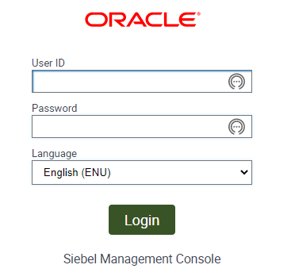

1. Review the Siebel Deployment Profile for your installation.

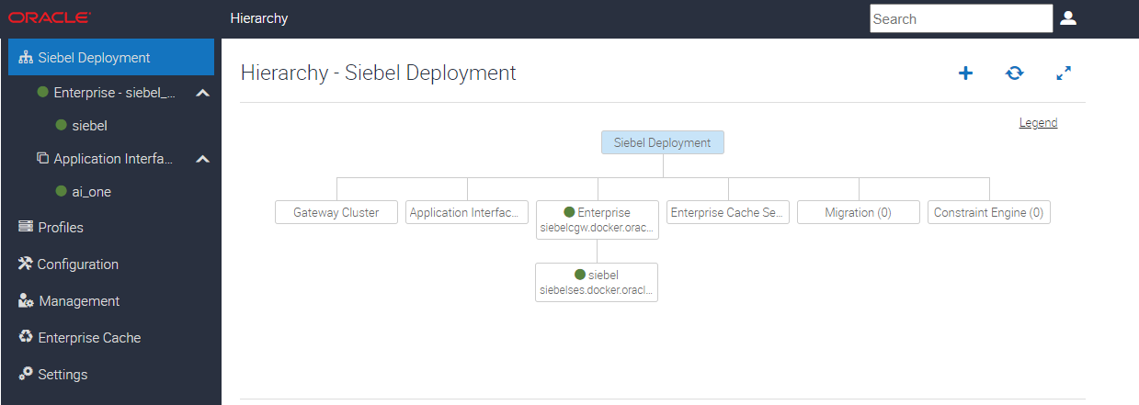

1. You will see an AI, Gateway Cluster, Siebel Server (4430) under Siebel Enterprise Server.

**Note:** As we explored profiles management in the lesson, you will observe the various profiles for each of the Siebel architectural components here.

1. Click on **Profiles** link in left navigation Pane.

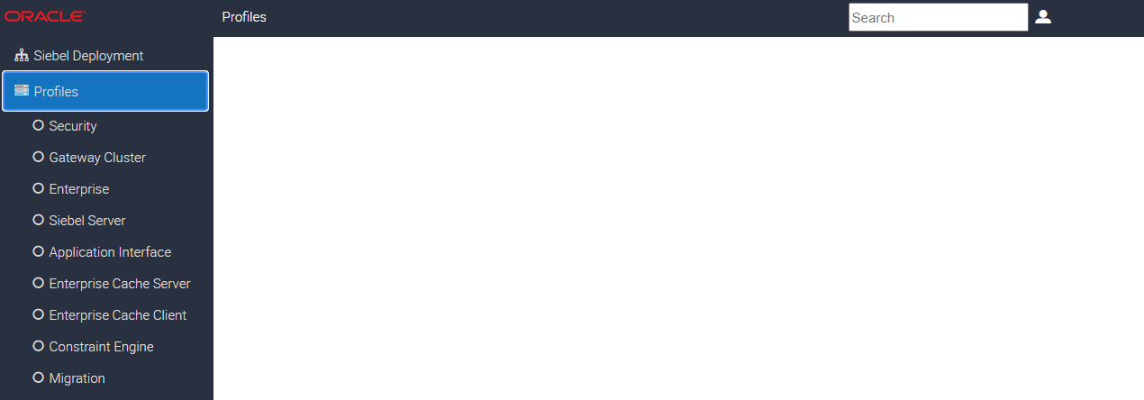

1. Click on **Security** under Profiles. This provides information about the Security Adapter. Click **Data Sources** Tab under the detailed page (default). You will be able to see the database and connection properties.

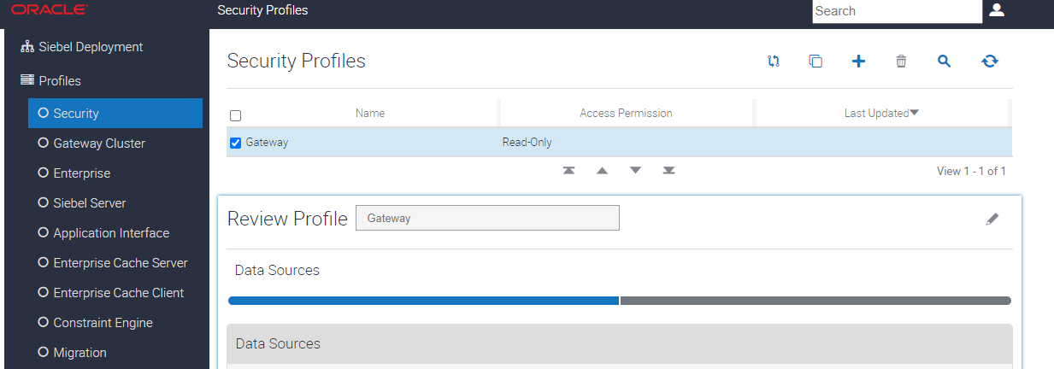

1. Now, click on **Security Information** Tab on the page. The details of security adapter will be displayed.

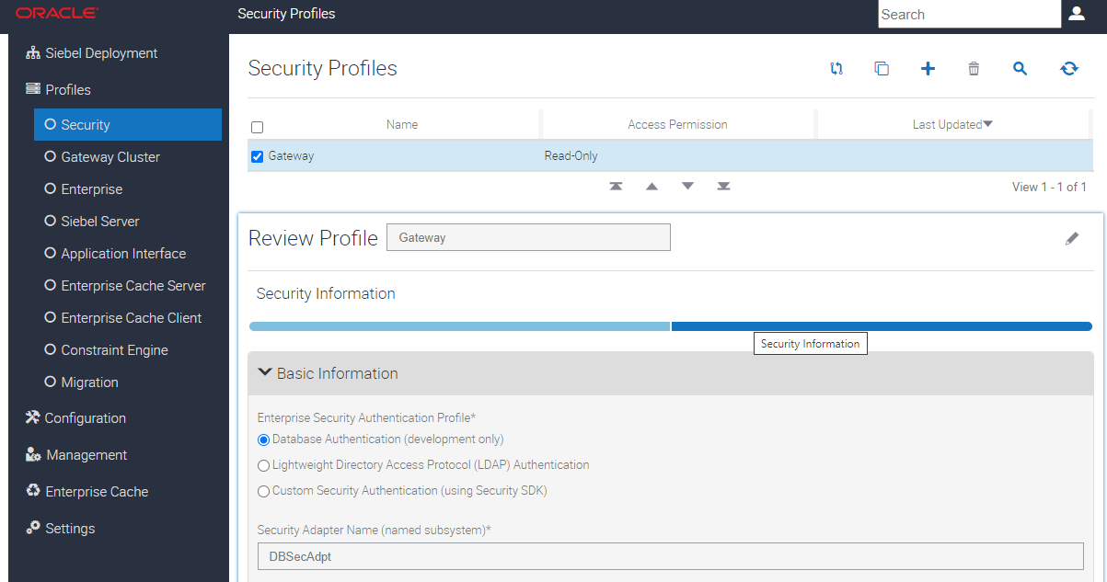

1. Click **Enterprise**.

Note: This page provides details of all Siebel servers in enterprise profile including authentication, gateway and security.   
Review the panes as below. you will see Gateway, Authentication and Security by clicking the tabs below..

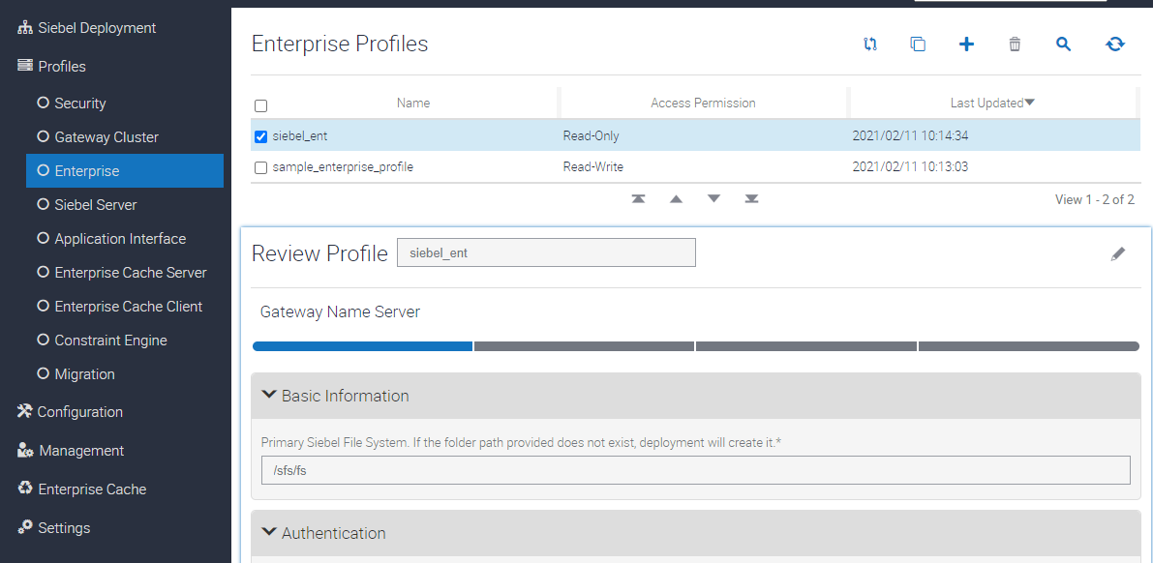

1. Now, click **Siebel Server** Profile. You will be able to see the different applications installed in the server.

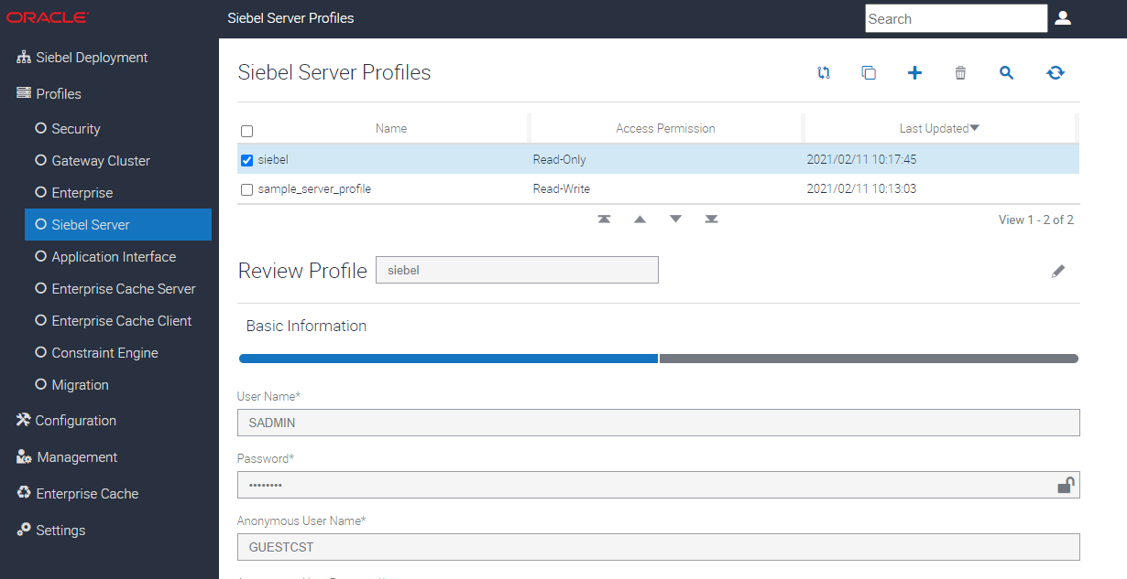

1. Under the Basic Information, the details of the App are shown below.

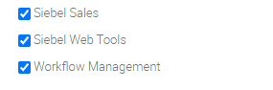

1. Now Let’s look at the AI Profile (**Application Interface**). The Criticality of webserver and its configuration is now available in this profile. Click on **Application Interface**.

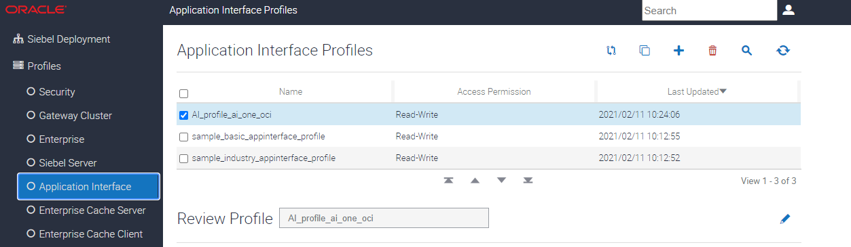

1. In the Basic Information, you can see the Logging (Expand Logging or Click Logging)

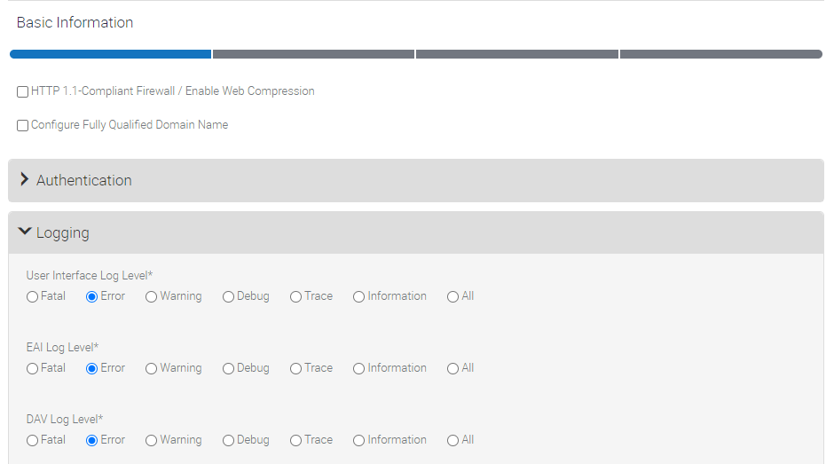

**Note:** Let’s move to Configuration Page. This is to review the parameters like your Server Configuration of the Administrative Application Screen.

1. To review the parameters in Server Configuration of the Administrative Application Screen, click **Component Definitions** available in the Siebel server.

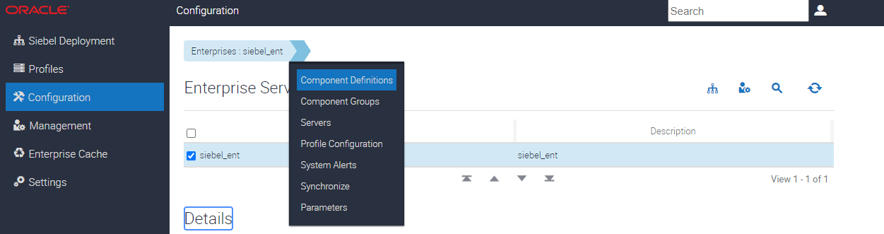

1. The details of the component and their status will be available. You can activate/deactivate components for your Siebel deployments accordingly.

**Note:** Any updates on the components can be synchronized through the synchronize button if need be.

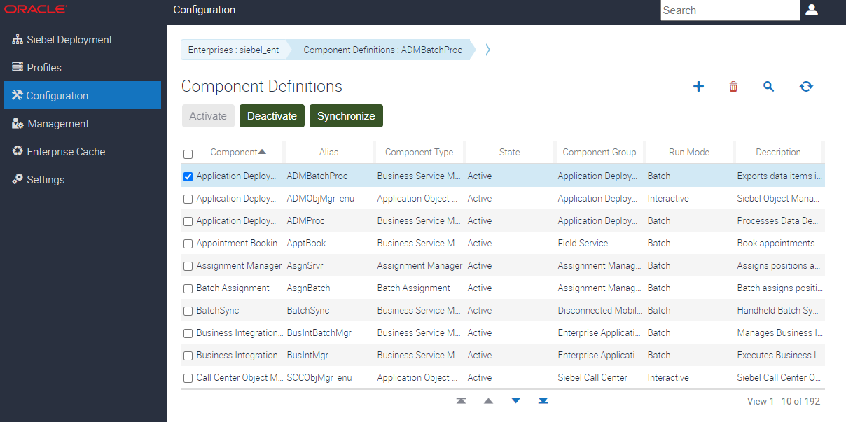

1. Click **Parameters** for the component definitions chosen. The parameters and properties will be shown for the selected components.

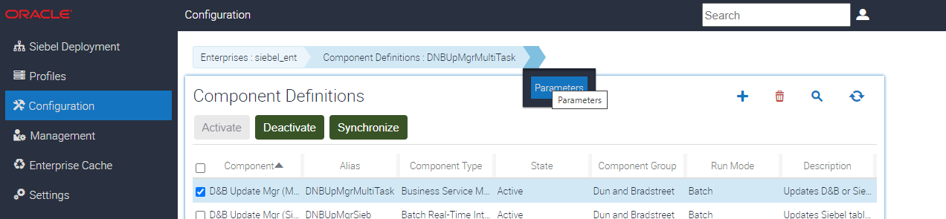

1. Now you can see the component parameter definition, name and value is available below. Click on **Advanced Button** to see more parameters defined.

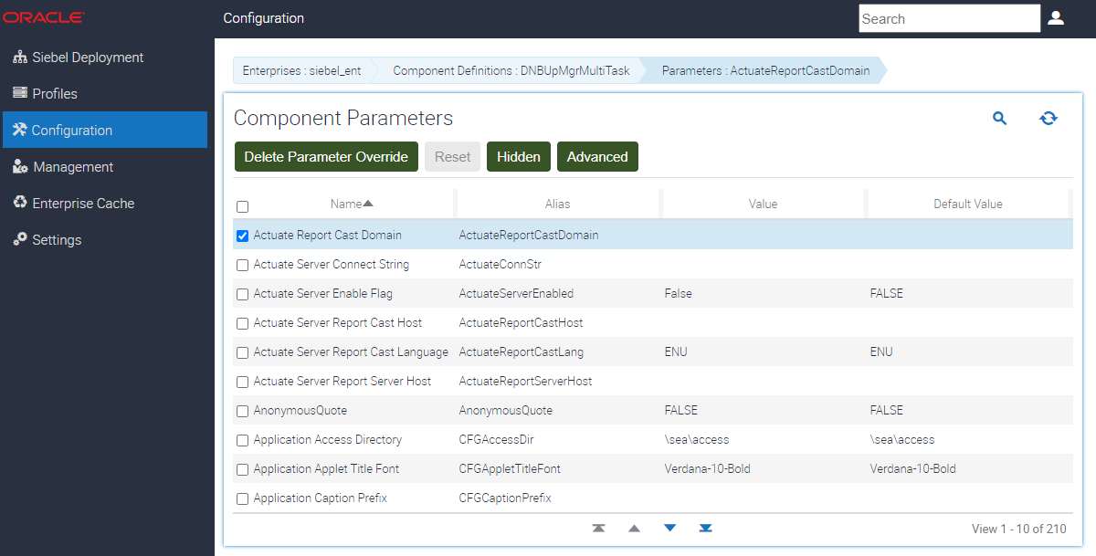

1. Choose **Component Groups** from Enterprise as below.

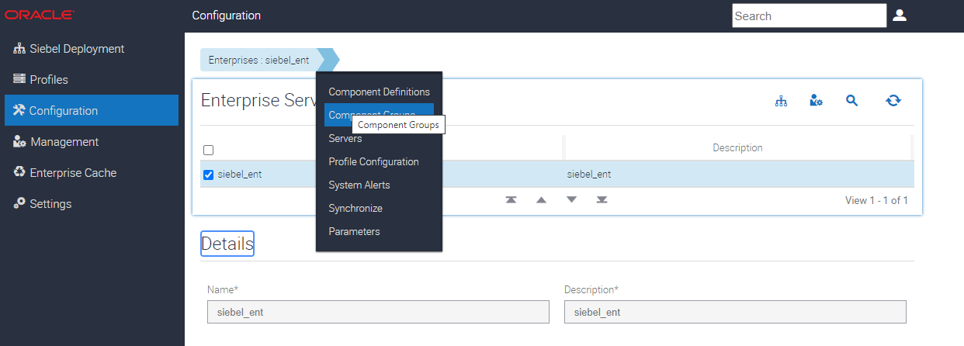

1. You can see which **Component Group** is visible to the Siebel Enterprise. You can add, enable and disable component group for your server. Here, **Application Deployment Manager** is enabled as shown below which is used for LOV Migration.

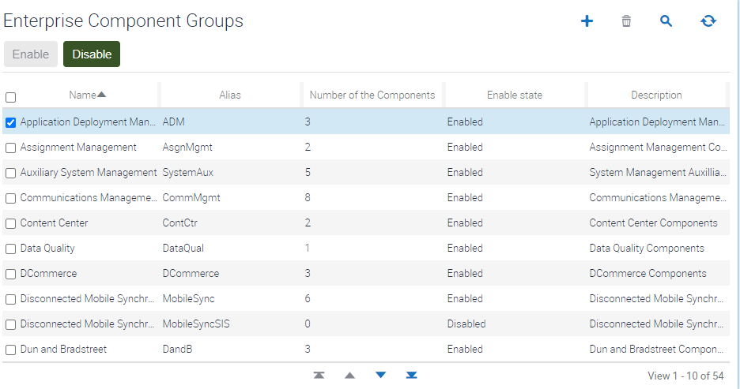

1. Under **Enterprise Server**, click **Parameters.**

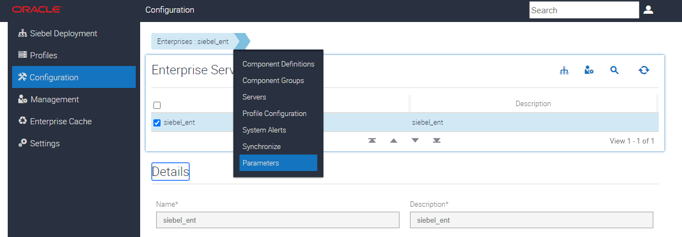

1. You will see the Parameters that are Enterprise Parameters. You can see the Parameter – **Admin Role Name** below – Like configuration parameters of Siebel Sever (Seen in Step 11), this can be overridden, deleted or modified.

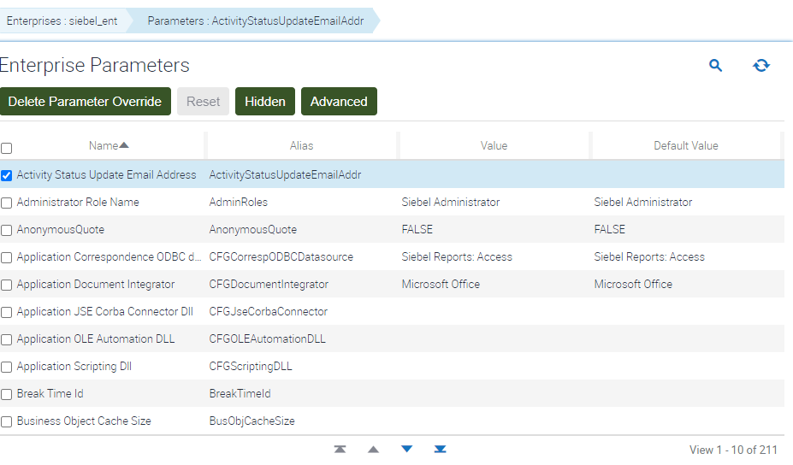

1. Click **Managemen**t Link in Left Navigation Menu

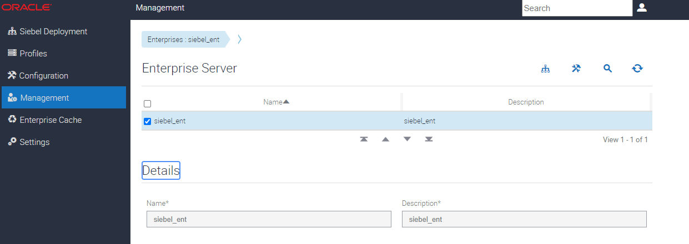

1. Click **on Servers** as shown below

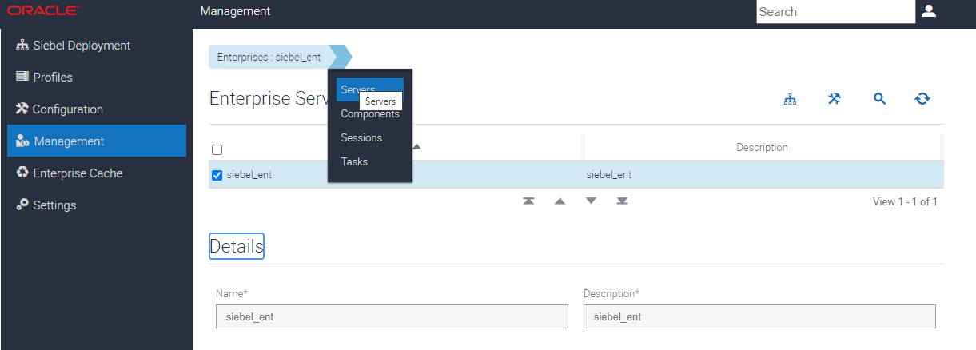

1. Here, you can start up and shutdown Siebel Server.   
   **Note:** In a project real case, there may be instance of many Siebel servers, you can start/stop specific Siebel server from this console window.

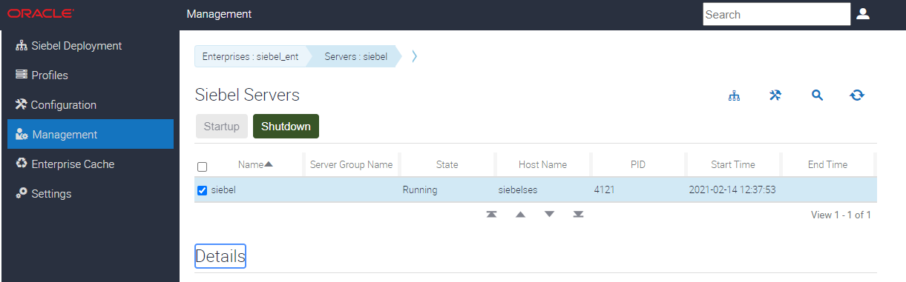

1. Click on the Icon for **Deployment** Properties to view the configuration. Click on **Management Link** on left navigation menu as shown below to come back to menu.

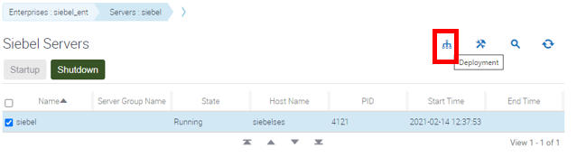

1. Review the Log information from SMC through Management link. Click on **Log** from the Server.

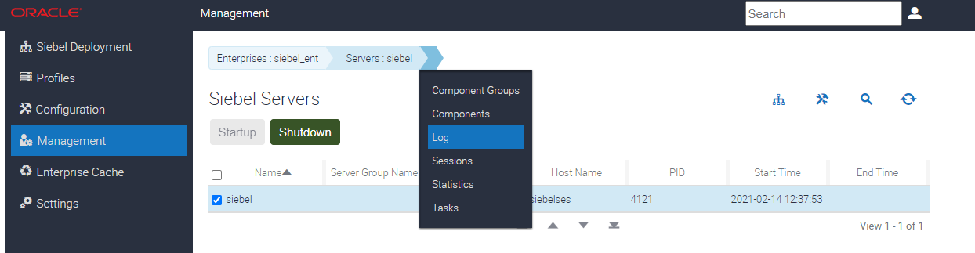

1. The information for Server Information Log will be displayed as shown below.

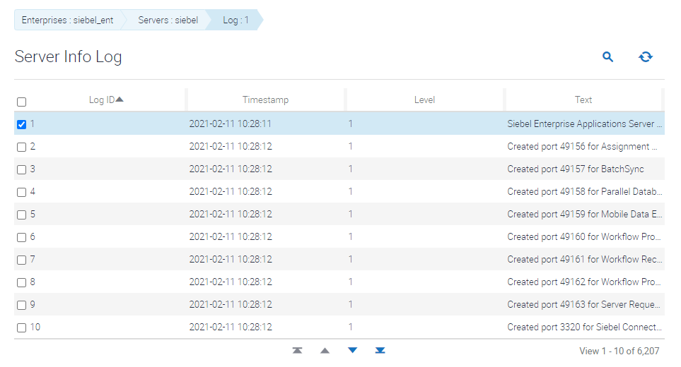

1. Click **Sessions** from Enterprise. This Provide Session Logs.

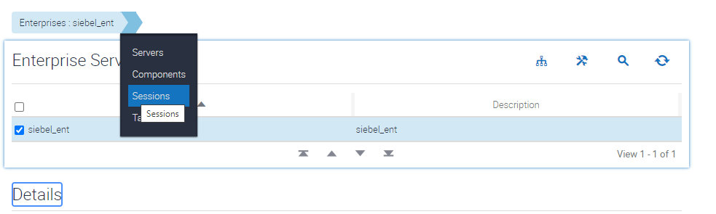

1. The Current Running/Closed Session History will be available. It can be **refreshed** if needed.

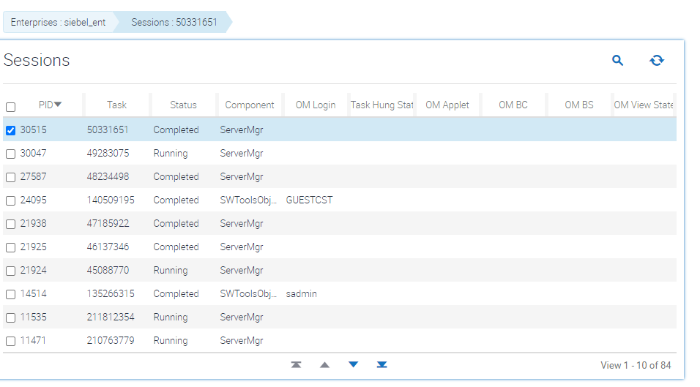

1. Click **Tasks** Log for Enterprise Server as shown below.

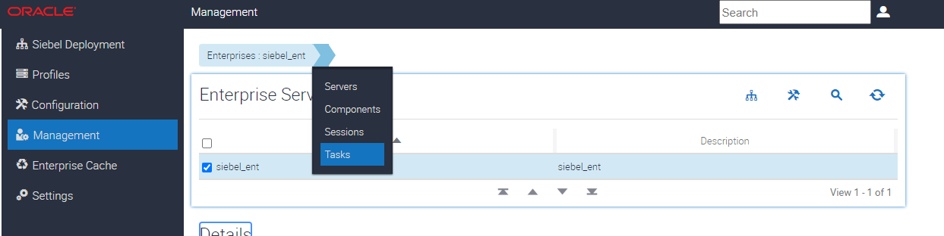

1. In Task Log, the status of each of the task with timestamp will be displayed as shown below.

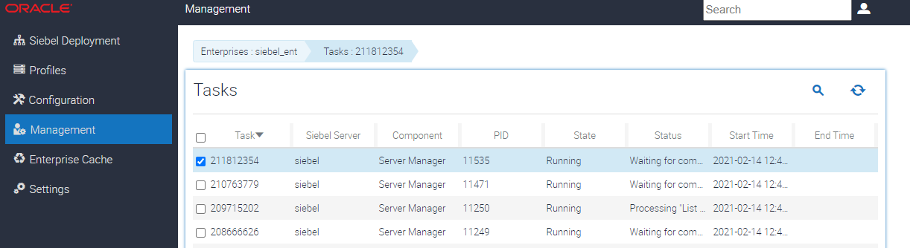

1. Click **Settings** from Left Navigation Pane. The Settings information will display the Gateway Log for the information.

